About the conference
会议情况介绍

The international reputable conference on AC and DC Power Transmission (ACDC) has been held once every two years for 15 times and in 2018 it was held in Chengdu, China with over 650 delegates attended. ACDC 2020 is coming back to China again to be held on 02-03 July in Xi’an, China, the Institution of Engineering and Technology (IET) is working with Tsinghua University to co-organize this event with. With a more attractive programme and comprehensive event scope, ACDC 2020 will be your opportunity to communicate with world-class researchers and industry leaders in the field of AC and DC power transmission.
IET交直流输电国际会议作为电力系统行业内久负盛名的高质量国际会议至今已成功举办15届。2018年ACDC会议在中国成都举办，参会嘉宾人数达650位。2020年第十六届ACDC会议由英国工程技术学会联手清华大学共同主办，将于2020年7月02-03日在中国古都西安举办，预计会议规模在700人左右。ACDC 2020具有多样化的会议形式以及丰富的会议体验，讨论内容涵盖当前热门话题与最前沿的科技成果。这将是贵司与交流直流输电行业领导者、世界一流的研究机构学者、业界专家以及专业技术人员交流沟通以及扩展专业人际圈的宝贵机会。

Audience
往届参会单位

Organisations & Universities:
多位行业技术骨干及百余位科研中坚力量参加会议，主要来自于 （排名不分先后）：

- Sichuan Energy Internet Research Institute, Tsinghua University
清华四川能源互联网研究院
- China Electric Power Research Institute (CEPRI)
中国电力科学研究院
- NARI Group Cooperation
南瑞集团
- Xuji Group Cooperation
许继集团
- China Southern Power Grid- EPRI
南网电科院
- RTDS Technologies
RTDS 技术公司
- Mitsubishi Electric Corporation
三菱电机
- Infineon
英飞凌
- Rong Xin Power Electronic Corporation
荣信电力电子公司
- Imperial College London
帝国理工学院
- KMITL
拉卡邦先皇理工学院
- Tsinghua University
清华大学
- North China Electric Power University
华北电力大学
- Harbin Institute of Technology
哈尔滨工业大学
- Huazhong University of Science and Technology
华中科技大学
- Xi’an Jiaotong University
西安交通大学
- Shanghai Jiao Tong University
上海交通大学
- Toshiba
东芝
- Sichuan Clean Energy Alliance
四川省清洁能源产业联盟
- China Energy Internet Alliance
国家能源互联网产业及技术创新联盟

Media Exposure
媒体报道

媒体圆桌 Media Roundtable
8 家媒体参加圆桌论坛，7家发稿 8 journalists from influential media attended MRT, and 7 released the press.
新闻稿 Press Release
1篇《第十四届IET交流直流电力传输国际会议 (ACDC)于成都成功举办》新闻稿于会议当天发出，产生44频次媒体报道 Press release was launched right after the event, which results in 44 exposures
深度稿 Feature Article
1篇《中国直流输电迅猛发展 成果普惠民生》深度稿于活动后发布，产生20频次媒体报道 Feature article was launched in the following weeks to further expand ACDC influence, which results in 20 exposures.

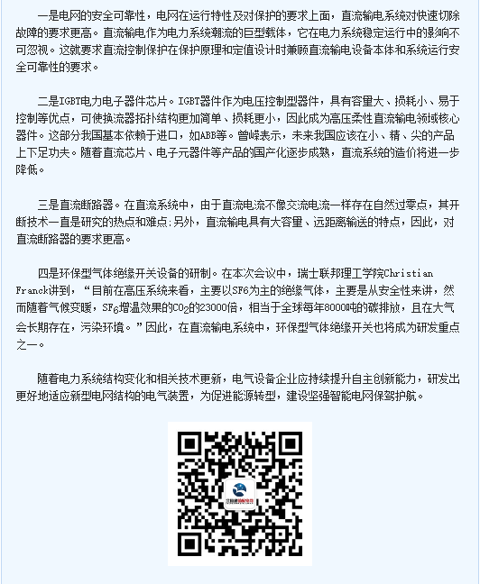
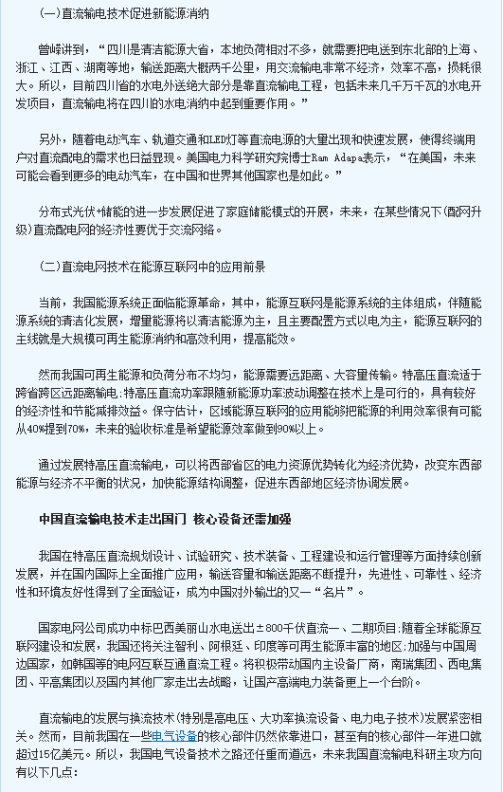
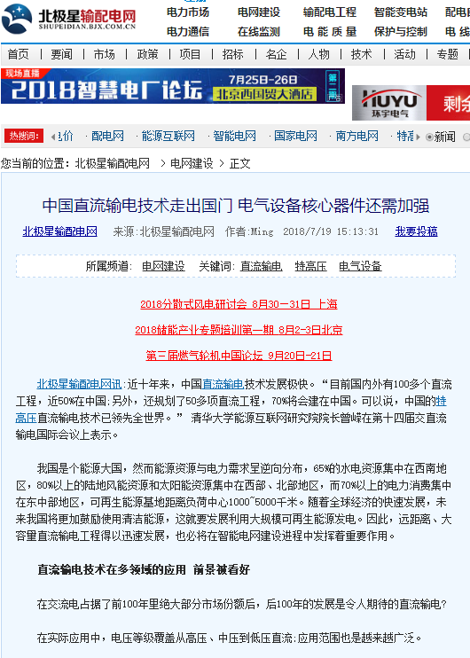

北极星电力网

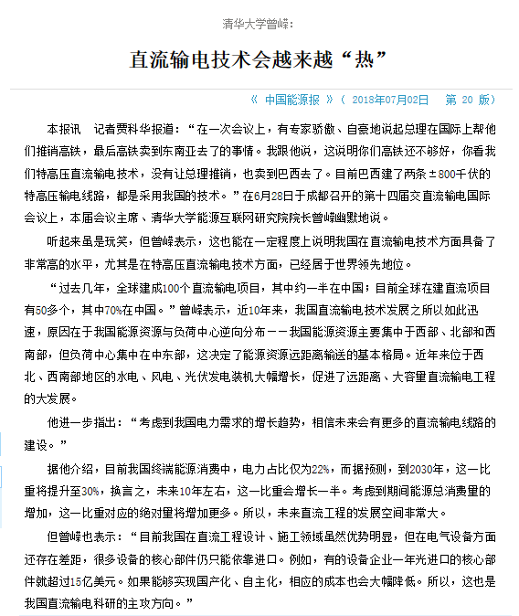
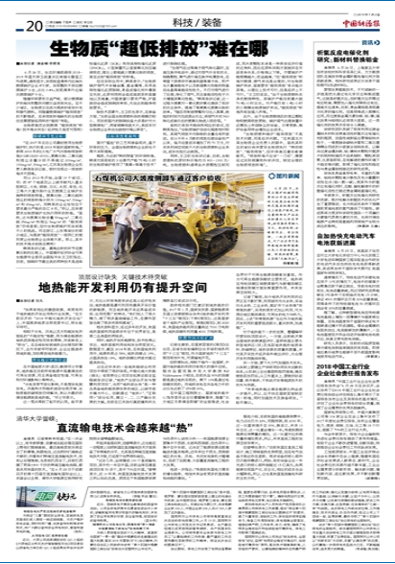

《中国能源报》
2018年7月2日 第20版

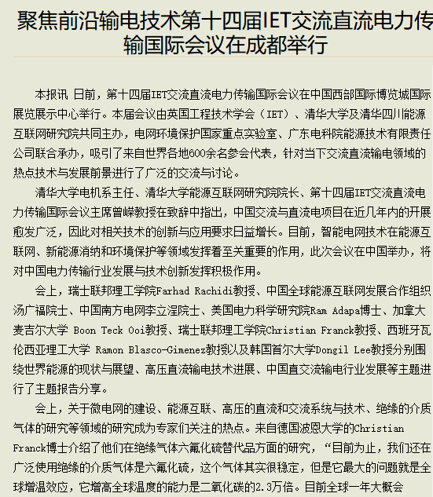
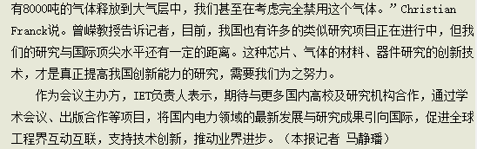
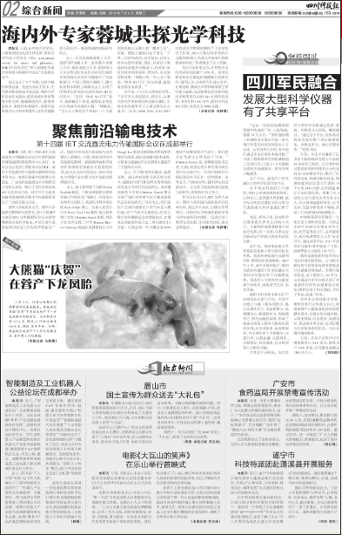

四川科技报：纸媒

《四川科技报》2018年7月4日 第2930期 第2版

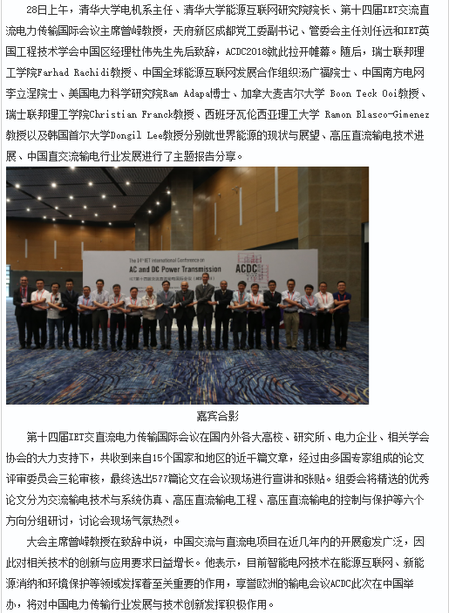
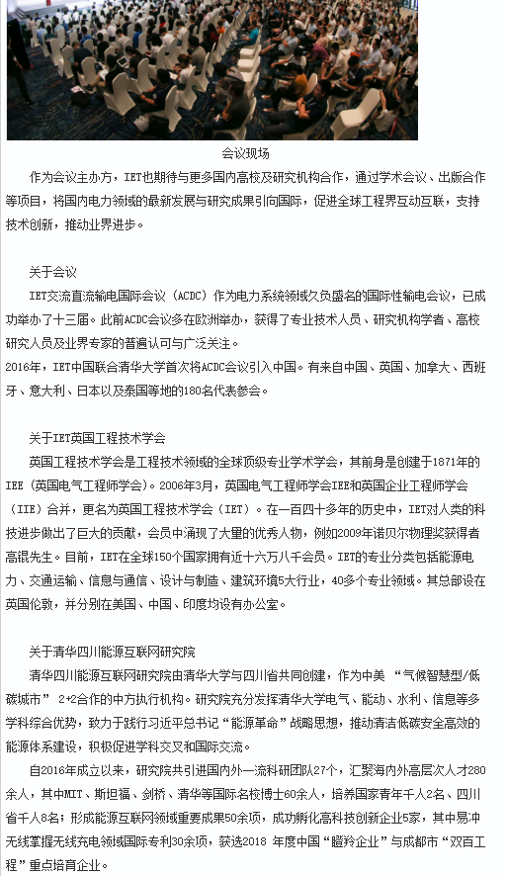
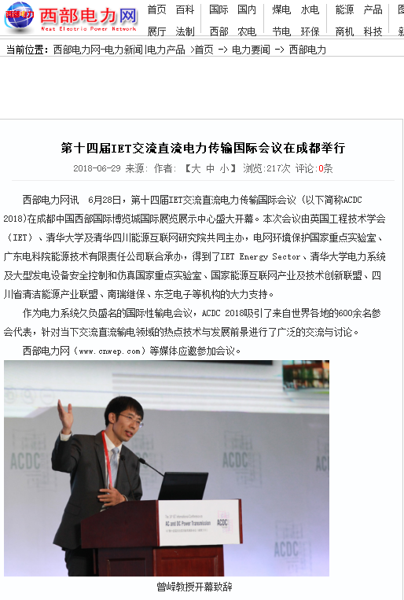

西部电力网http://www.cnwep.com/bencandy.php?fid=31&id=506388

